**What is Machine Learning?**

Machine learning (ML) is a type of artificial intelligence ([AI](https://www.techtarget.com/searchenterpriseai/definition/AI-Artificial-Intelligence)) focused on building computer systems that learn from data.

Machine learning (ML) is a branch of [artificial intelligence (AI)](https://www.ibm.com/topics/artificial-intelligence) and computer science that focuses on the using data and algorithms to enable AI to imitate the way that humans learn, gradually improving its accuracy.

**How does machine learning work?**

1. **A Decision Process:** In general, machine learning algorithms are used to make predictions or classification. Based on some input data, which can be labeled or unlabeled, your algorithm will produce an estimate about a pattern in the data.
2. **An Error Function:** An error function evaluates the prediction of the model. If there are known examples, an error function can make a comparison to assess the accuracy of the model.
3. **A Model Optimization Process**: If the model can fit better to the data points in the training set, then weights are adjusted to reduce the discrepancy between the known example and the model estimate. The algorithm will repeat this iterative “evaluate and optimize” process, updating weights autonomously until a threshold of accuracy has been met.

**ML Applications:**

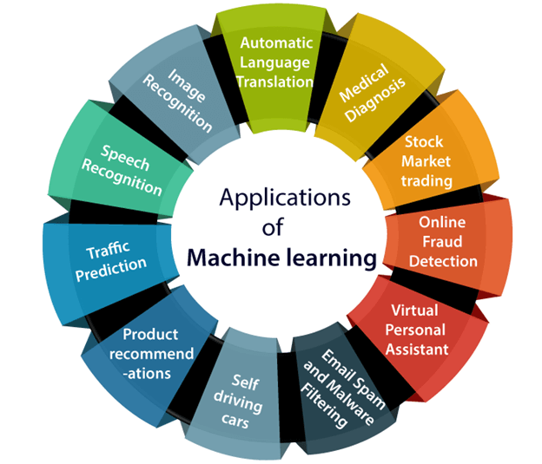

We are using machine learning in our daily life even without knowing it such as Google Maps, Google assistant, Alexa, etc.

**Image Recognition:**

Image recognition is one of the most common applications of machine learning. It is used to identify objects, persons, places, digital images, etc. The popular use case of image recognition and face detection is, Automatic friend tagging suggestion

The technology behind this is machine learning's **face detection** and **recognition algorithm**.

It is based on the Facebook project named "**Deep Face**," which is responsible for face recognition and person identification in the picture.

**Speech Recognition:**

While using Google, we get an option of "Search by voice," it comes under speech recognition, and it's a popular application of machine learning.

Speech recognition is a process of converting voice instructions into text, and it is also known as "Speech to text", or "Computer speech recognition." At present, machine learning algorithms are widely used by various applications of speech recognition. Google assistants, Siri, Cortana, and Alexa are using speech recognition technology to follow the voice instructions.

**Self-driving cars:**

One of the most exciting applications of machine learning is self-driving cars. Machine learning plays a significant role in self-driving cars. Tesla, the most popular car manufacturing company, is working on self-driving car. It is using unsupervised learning methods to train the car models to detect people and objects while driving.

### **Automatic Language Translation:**

Nowadays, if we visit a new place and we are not aware of the language then it is not a problem at all, as for this also machine learning helps us by converting the text into our known languages. Google's GNMT (Google Neural Machine Translation) provide this feature, which is a Neural Machine Learning that translates the text into our familiar language, and it called as automatic translation.

The technology behind the automatic translation is a sequence to sequence learning algorithm, which is used with image recognition and translates the text from one language to another language.

**ML Use Cases:**

Use case - a specific situation in which a product or service could potentially be used.

**Machine learning in marketing and sales:**

ML algorithms and data science are how recommendation engines at sites like Amazon, Netflix and StitchFix make recommendations based on a user’s taste, browsing and shopping cart history. ML also helps drive personalized marketing initiatives

## **Customer service use cases:**

Text-based queries are usually handled by chatbots, virtual agents that most businesses provide on their e-commerce sites. Such chatbots ensure that customers don’t have to wait, and even large numbers of simultaneous customers can get immediate attention around the clock and, hopefully, a more positive customer experience.

**Personal assistants and voice assistants:**

It’s ML that powers the tasks done by virtual personal assistants or voice assistants, such as Amazon’s Alexa and Apple’s Siri. This communication can involve speech recognition, speech-to-text conversion, NLP, or text-to-speech. When someone asks a virtual assistant a question, ML searches for the answer or recalls similar questions the person has asked before.

ML is also behind messaging bots, such as those used by Facebook Messenger and Slack.

**Filtering email:**

ML algorithms in Google’s Gmail automate filtering customers’ email into Primary, Social and Promotions categories while also detecting and rerouting spam to a spam folder. Going beyond email app “rules,” ML tools can also automate email management

**Machine learning in healthcare:**

ML developments led to training machines in pattern recognition, which is now sometimes used in radiology imaging. [AI-enabled computer vision](https://research.aimultiple.com/radiology-ai/) is often used to analyze mammograms and for early lung cancer screening.

ML is also trained and used to classify tumors, find bone fractures that are hard to see with the human eye and detect neurological disorders.

# **Machine Learning Systems**

A machine learning system is a computer system that is responsible for managing the data and the programs that train and operate the machine learning models that power an AI-enabled application or service.

## **Four types of Machine Learning Systems**

[Machine learning](https://www.hopsworks.ai/dictionary/ml) systems (ML systems) can be categorized into four different types:

* **real-time** interactive applications that take user input and use a model to make a prediction;
* **batch** applications that use models to make predictions on a schedule;
* **stream** processing applications that use models to make predictions on streaming data;
* **embedded/**edge applications that use models and sensors in resource constrained environments.

The following are examples of the four different types of machine learning systems:

### **Batch ML Systems**

**Dashboards**are built from predictions made by a batch ML system.  
[Predict Air Quality](https://www.youtube.com/watch?v=dgBFShBuV4k) - take observations of air quality from sensors and use weather as features for predicting air quality. A dashboard can predict air quality by using the weather forecast (input features) to predict air quality (target).

**Interactive Systems** that use predictions made by a batch ML system.[Google Photos Search](https://developers.google.com/machine-learning/practica/image-classification) - when your photos are uploaded to Google, it runs a classification model to identify things and places in the photo. Those things/places are indexed against the photo, so that you can search in free-text to find matching photos. For example, if you type in “bike”, it will show you your photos that have one or more bicycles in them.

### **Stream Processing ML Systems**

* Real-time pattern matching systems that do not require user input are often stream processing ML systems.
* Network Intrusion Detection - if you use stream processing to extract features about all traffic in a network, you can then use a model to predict anomalies such as network intrusion.

### **Real-Time ML Systems**

* Interactive systems that make predictions based on user input.  
  [ChatGPT](https://chat.openai.com/auth/login) is an example of a system that takes user input (a prompt) and returns an answer in text.
* [Tiktok](https://arxiv.org/pdf/2209.07663.pdf) builds its personalized recommendations engine using ML and a real-time feature store that provides historical user information and context to better personalize recommendations.

### **Embedded or Edge ML Systems**

* Real-time pattern matching systems that run on resource-constrained or network detached devices.
* [Tesla Autopilot](https://en.wikipedia.org/wiki/Tesla_Autopilot) is an driver assist system powered by ML that uses sensors from cameras and other systems to help the ML models make predictions about what driving actions to take (steering, acceleration, braking, etc).

***Thank you***